Excel Sales Analysis Report

**Introduction:**

This project involved a comprehensive analysis of sales data, focusing on product categories, sales areas, top performers, and key metrics. The analysis was conducted using Microsoft Excel.

**Project Overview:**

The goal was to gain insights into the sales distribution, top-performing areas, employees, and customers, as well as overall performance metrics.

**Key Findings:**

1. **Product Category Distribution:**

- Widgets: 50%

- Junk: 23%

- Things: 16%

- Stuff: 11%

1. **Top Sales Areas:**

- New York: $163,000

- Washington: $149,000

- Minnesota: $100,000

*Note: These regions contribute significantly to the overall sales volume.*

1. **Top Sales Employees:**

- Sara Snyder: $268,000

- Patrick Graham: $168,000

- Randy Watson: $113,000

1. **Best Customers:**

- Joan Robinson

- Judy Lopez

- Helen Diaz

1. **Overall Performance Metrics:**

- Total articles sold: 31,396

- Total sales amount: $719,771

- Profit: $104,525

*Note: The company achieved profitability and a notable sales volume.*

1. **Peak Sales Month:**

- December recorded the highest sales with a total of $119,606.

**Insights:**

Understanding the distribution of product categories, top-performing areas, employees, and customers provides valuable insights for strategic decision-making and future planning.

**Visuals:**

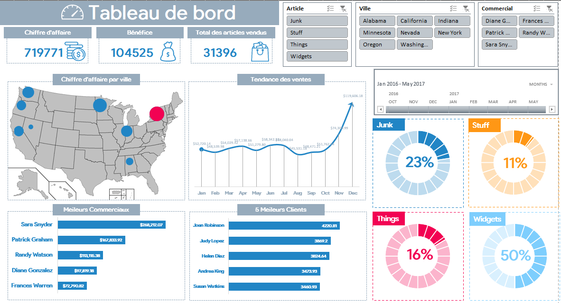

**Challenges:**

One notable challenge during the project was the need to enhance data visualization using Excel. While I was already familiar with Excel, delving into advanced data visualization techniques, especially utilizing pivot tables in a new and effective manner, required a learning curve. Through dedicated efforts and exploration, I gained valuable insights into leveraging Excel's capabilities for more sophisticated data representation. This experience not only enriched my skill set but also improved the overall quality of the analysis and reporting.

**Call-to-Action:**

For a more detailed exploration of the sales dynamics, refer to the comprehensive Sales Analysis Dashboard. [Link](https://drive.google.com/drive/folders/1vWUnP2JoGUSZC0jFvVZ1Qaij7JieTQR5?usp=drive_link)

**Contact Information:**

For inquiries or collaboration opportunities, please contact:

- Coumba COULIBALY

- Email: coumbacoulibaly09@gmail.com

- LinkedIn: [www.linkedin.com/in/coumba-coulibaly](http://www.linkedin.com/in/coumba-coulibaly)